MTH 101 Lab: Probability in Health and Risk Section: ________________________________
Name:
_____________________________________________________________________________________

Focus Question:
- What can probability tell us about health questions that affect us?
  - What can it say about incorrect medical test results?
  - How does this relate to today’s world?
Interpreting Medical Test Results

Definition: When someone has a medical test, they can either receive a positive or negative test result. A positive test result means that the test indicated that the individual has the condition. A negative test result means that the test indicated the individual does not have the condition.

Definition: A medical test can be incorrect. To account for this, we say a true/false positive/negative test results. Specifically,
- We say that a result is a true positive if the patient has the condition and received a positive test result. In this case, the test is correct.
- We say that a result is a false positive if the patient does not have the condition but received a positive test result. In this case, the test is incorrect.
- We say that a result is a true negative if the patient does not have the condition and received a negative test result. In this case, the test is correct.
- We say that a result is a false negative if the patient has the condition but received a negative test result. In this case, the test is incorrect.

Specifically, we shall look at the validity of the rapid strep test.
- According to the CDC, about 15% of adults who go to the doctor with a sore throat will have strep throat.
- If a patient does have strep throat, there is a 64.6% probability that the rapid strep test will give a positive test result. This number (64.6%) is called the sensitivity of the rapid strep test.
- If a patient does not have strep throat, there is a 96.8% probability that the rapid strep test will give a negative test result. This number (96.8% is called the specificity of the rapid strep test.
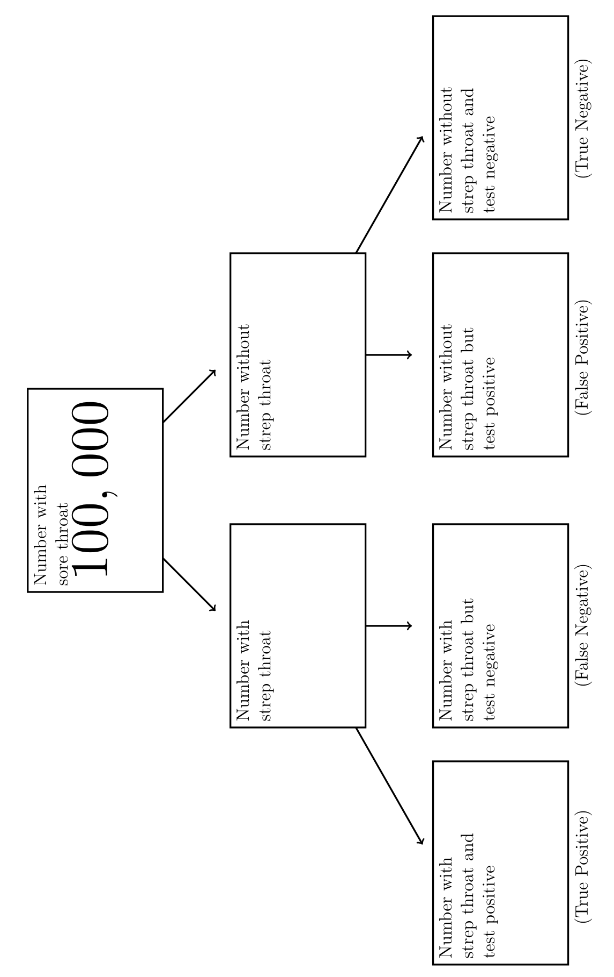
Using this information, answer the following questions:

- Let’s suppose that 100,000 people go into the doctor for a sore throat. To test if they actually have strep throat, the doctor gives them a rapid strep test. Using the information above, fill out the tree diagram below:

- Of those people who tested positive, what percent have strep throat? This percentage is called the positive predictive value (PPV).
- Complete the following sentence:

We can conclude that out of every 100 people who test positive for strep throat using the rapid strep test, about ___________ will not have strep throat and ______________ will have strep throat.

- Of those people who tested negative, what percent do not have strep throat? This percentage is called the negative predictive value (NPV).

- Complete the following sentence:

We can conclude that out of every 100 people who test negative for strep throat using the rapid strep test, about ____________ will not have strep throat and ______________ will have strep throat.

- If we change the number of people with sore throats from 100,000 to 5,000 will the NPV or PPV change?

Part II

What happens if instead of testing 100,000 people with sore throats, doctors just went around the streets and administered strep throat tests to 1,000,000 random people?

- The 15% prevalence for strep throat would go ________ (up/down).

- Will the sensitivity or specificity of the test change?

- What about the PPV and NPV? One will go up and one will go down, which is which?

- Pick the 2 true sentences out of the following:
  - The NPV will go up, meaning that the test is better at telling you that you do not have strep.
  - The NPV will go down, meaning that the test has a better chance of giving you a false negative, and missing your diagnosis.
  - The PPV will go up, meaning that the test has a better chance of accurately saying you do have strep.
  - The PPV will go down, meaning that there are more false positives, causing unnecessary panic for many people.

Many countries have been criticized for their policies of testing people for the coronavirus. For example, just a few weeks ago, in the United States, even if you were feeling very ill, you could not get tested unless you had traveled to an affected area or had been in close contact with someone who had a confirmed diagnosis.

Let’s pretend there were an ample number of tests available, so these policies were not a result of a lack of testing capability.

Using ONLY mathematical reasoning from the prior example in Part II, see if you can explain these testing policies from the point of view of the governments offering the test. This is not the place to get on your political or economic soapbox.

The answer should be something like this (this is wrong) “There was such a strict testing policy because the government knew that testing a lot more people who were at low risk for the virus would create many more false negative test results and a lot of people would go undiagnosed.”

Explain in a complete sentence whether you think the specificity or sensitivity of a test is more important and why. (Both answers could be right.)

Participation | ____/5
Correctness | ____/5
TOTAL | ____/10

https://www.cdc.gov/groupastrep/diseases-hcp/strep-throat.html (2018)
The sensitivity and the specificity of rapid antigen test in streptococcal upper respiratory tract infections (2010)
The sensitivity and the specificity of rapid antigen test in streptococcal upper respiratory tract infections (2010)

