Name: ____________________________________________________________________

Answer the following questions based on the article “Income Inequality in the U.S. is Rising Most Rapidly Among Asians” by Rakesh Kochhar and Anthony Cilluffo. A printout is provided and the figure and page numbers referenced in this exam correspond to that printout.

- What does the number 9.8 in Fig. A indicate? Circle ONE.
  - In 2016, the income of blacks in the 90th percentile of the income distribution was 9.8 times higher than it was in 1970.
  - In 2016, the 90th percentile of the income distribution was 9.8% blacks.
  - In 2016, 9.8% of blacks earned in the 90th percentile of the income distribution.
  - In 2016, blacks in the top 10% of the income distribution earned 9.8 times as much as blacks in the bottom 10%.

- Use Fig. B to answer the following questions.
  - According to Fig. B, the 10th percentile of Asians have the lowest income of any other race or ethnicity category represented on the chart.
TRUE FALSE
  - Explain your answer to part (a)

- Using Fig. C, fill in the following blanks:

  - In 2016, _____% of Asians earned more than $51,288.
  - In 2016, _____% of Asians earned more than $133,529.

  - In 2016, _____% of Asians earned more than $12,478.

- What does the number “-11” in Fig. E indicate? Circle ONE.
  - From 2000 to 2016, the income of Americans in the 10th percentile of the income distribution decreased by 11%.
  - From 2000 to 2016, Americans in the 10th percentile of the income distribution earned 11% less than they earned between 1970 and 2000.
  - From 2000 to 2016, there were 11% fewer people in the 10th percentile of the income distribution.
  - From 1970 to 2016, there was an overall decrease of 11% of income.

- Use Fig. F to determine if the following statements are true. Circle TRUE or FALSE for each statement.
  - The fact that the 90/10 ratio is 10.7 for Asians and 7.8 for Hispanics does not necessarily mean that average income of Asians is higher than that of Hispanics.
TRUE FALSE
  - To find the 90/10 ratio for All, you can average the numbers 7.8, 7.8, 9.8, 10.7.
TRUE FALSE

  - Because the 90/10 ratio for Hispanics and Whites is the same, this means that on average Hispanics and Whites earn the same income.
TRUE FALSE

- What does the number 72 on Fig. G on indicate? Circle ONE.
  - In 1970, the income of Hispanics went from 65% to 72% of whites’ income in the course of the year.
  - In 1970, 72 Hispanics in the 95th percentile of the income distribution made more than 100 whites.
  - In 1970, Hispanics in the 95th percentile of the income distribution made 72% of the income of whites in the 95th percentile of the income distribution.
  - In 1970, 72% of Hispanics earned as much as whites in the 95th percentile of income distribution.

Answer the following questions based on the article “Happiness and Life Satisfaction” by Esteban Ortiz-Ospina and Max Roser. A printout is provided and the figure and page numbers referenced in this exam correspond to that printout.

- Consider Fig. 1. Circle TRUE or FALSE for each statement.
Note that the “blue markers” referenced in your black-and-white printout are the horizontal black dashes.
  - The number of people in the World who answered “5” for the level of their life satisfaction is about double the number of people in the World who answered “4” for the level of their life satisfaction.
TRUE FALSE
  - The number of people in Western Europe who answered “8” for the level of their life satisfaction is about twice as many as the number of people in the World who answered “8” for the level of their life satisfaction.
TRUE FALSE
  - The proportion of people in Western Europe who answered “8” for the level of their life satisfaction is about double the proportion of people in the World who answered “8” for the level of their life satisfaction.
TRUE FALSE

- Consider Fig. 4. Circle TRUE or FALSE for each statement.
  - From Fig. 4 we can deduce that a person who is happy and follows their passion will make more money.
TRUE or FALSE
  - From Fig. 4 we can deduce that a person with more money will have higher life satisfaction than a person with less money.
TRUE or FALSE

- Consider Fig. 4.
  - GDP per capita and average life satisfaction are

Not correlated Positively correlated Negatively correlated

  - If you stated that the variables are positively/negatively correlated, explain in a complete sentence why GDP per capita may be positively/negatively correlated with average life satisfaction. If you stated that there was no correlation, explain your reasoning.

- Use Fig. 4 to determine if the following statements are true. Circle TRUE or FALSE for each statement.
  - GDP per capita is a relative measure.
TRUE FALSE

  - The reason that China has a higher GDP per capita than Liberia is that China has a higher population.
TRUE FALSE

General Questions:
- Given the statement: Americans spend approximately 500 billion dollars on pizza every year.
  - Is this statement reasonable or unreasonable?
  - Explain your answer to part (a). You must show your work.
- The final exam scores for STT 200 were normally distributed with a mean of 75 points and a standard deviation of 5 points. Use the 68-95-99.7 rule to find the percent of students who scored 70 or above points on the exam.
- (4 points) A graph similar to the one below was used by a public media source to show support for a court decision.
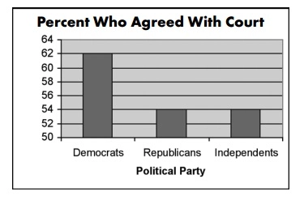
Why is this graph misleading? Answer in a complete sentence.
- Suppose a new test is developed to test for mono. Suppose that about 5% of people who go to the doctor with fatigue will have mono. Suppose this new test has a sensitivity of 90% and a specificity of 80%. Fill in the tree diagram below.

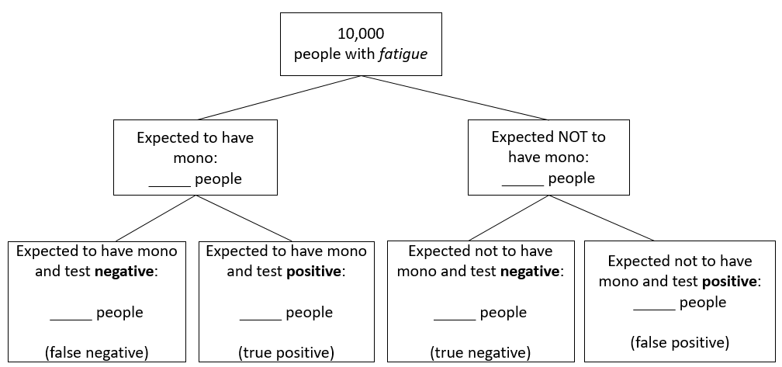

Suppose Amanda has fatigue, goes to the doctor, takes the test, and receives a negative result.
- There is a ____________ % chance that Amanda does NOT have mono (NPV).

- There is a ____________ % chance that Amanda has mono.

